When Robot Bleed GDD

Version1.1

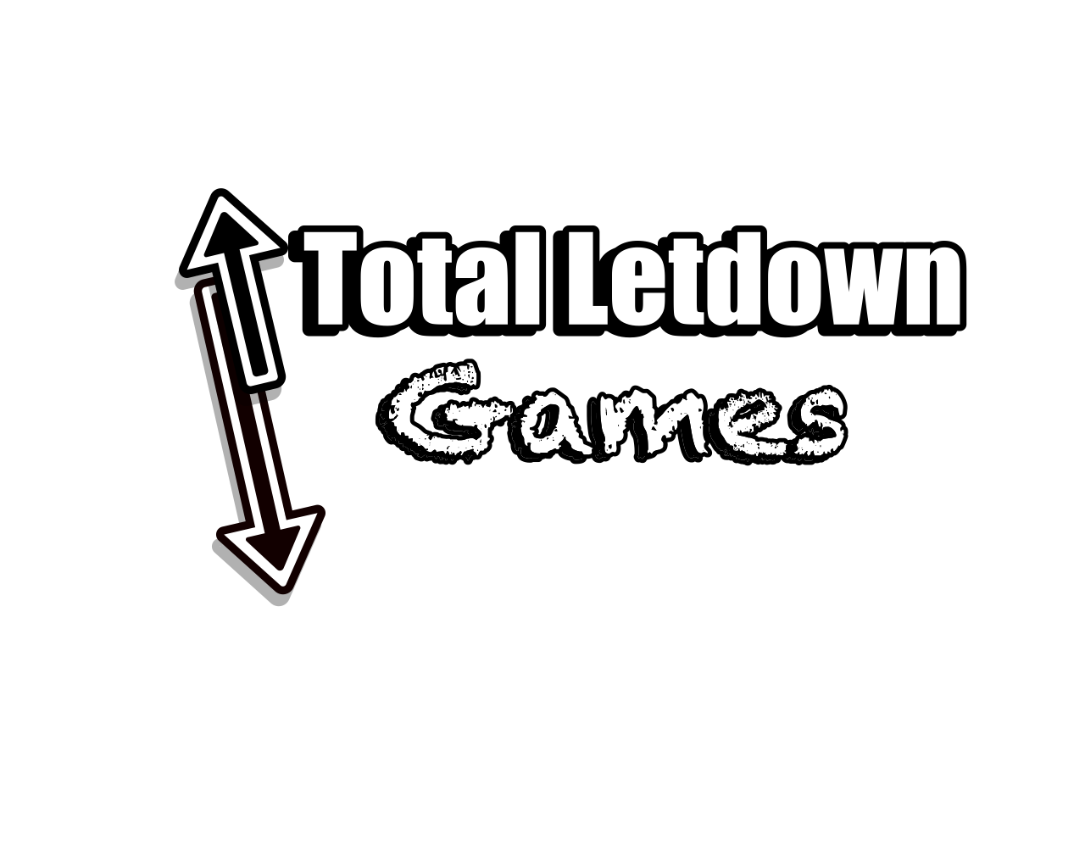

By

Team Members: Joseph Pak, Simi Virdi, Emanuel Dorsey, Robert Newman, Laila Abuelhawa, Jason Leung, Marcus Queiro, Wyatt, Raphael Brown.

2/22/2023

Game Overview 3

Gameplay and Mechanics 4

Main Objective of the game 4

Game Progressions 4

Player Mechanics 4

Unlockable ability and upgrade 4

Controls 6

Story, Setting, and Character 7

Levels 9

Area 1: Factory Junkyard 10

Area 2: Magma Metal Factory 11

Area 3: Storage Room 12

Area 4: Old Garden 13

Area 5: The Lab 14

Level MOCKUP Pics 15

Area 1: 15

**Interface** 16

**Audio** 18

**Music** 18

**Sound Effects** 19

Enemies and Bosses 20

Technical 22

Game Art 24

# Game Overview

**The main concept of the game**:You play a broken-down robot that has to awaken in a broken-down factory.

**Unique Features**:

* Deal with hard and challenge enemies that will constantly try to kill you in every corner
* Special Bots that will chase you relentlessly making you run away and having to hide to escape from them created a terror of an experience.
* Emercel Experience this world that has been lost to humanity and All that remains in this desolate world are the few remaining robots that humanity created.
* Enjoy exploring and being lost in a giddy and lost factory that will make you feel alone.

**Genre**: a 2d Metroidvania platformer with an element of survival horror.

**Target Audience**

The target audience for the game is PC gamers, particularly Steam users, who enjoy 2D platformers and Metroidvania-style games.

Age:13 and up

**Game Flow Summary**

To destroy the threat causing robots to destroy each other and escape the factory. Explore the factory and make your way to the final area where the main threat is hidden. Each area holds a special keycard that progresses the game. After collecting 4 key cards, the final area is unlocked and you take on the final boss in order to save all bots.

# Gameplay and Mechanics

## Main Objective of the game

To destroy the AI that is causing most robots to kill each other and get out of the factory. But to do that you need to keep exploring the factor and get to the last area where the AI is hidden. Each of the areas will have a special key card that will help in progressing the game. When you get all 4 key cards the final area opens and then you take on the final boss who is the AI that you must destroy to save all bots.

## Game Progressions

The player will progress through the game by opening the facility and trying to get to the AI. In order to progress in the game, the player will need to gain a critical ability that will help in opening new areas However when getting the abilities for the first time it will trigger the alarm system and cause the activation of a special enemy that will chase down the player. This enemy is unkillable and can only be stopped after the sequence is over. After the sequence is over the player can then backtrack and unlock the next new area to explore. Each of the areas will hold one boss that will have one of the special keycards needed for the end game. Defeating them will give the player these key cards as well as an upgrade to one of the player's abilities.

## Player Mechanics

The Player will have a hp meter starting with 100 hp and can be upgraded to increase the amount. The player will take damage from the environment and from enemies.

The player will also have an energy meter of around 50 energy and this is used as a resource to be able to use weapons like a gun and sword beam.

For example, the gun will take 10 energy per shot.

When depleted the player will need to restore it by collecting energy dropped by enemies when defeated or from boxes being destroyed.

The player can also wait a bit to restore their energy but only by a bit.

(usually enough for 2 shots)

Defeating the enemy will give EXP to the player that can be used to upgrade even more of the player's skills. Another way of gaining a level is by finding orbs hidden in the world that will also give EXP

## Unlockable ability and upgrade

* In the game, the player will be able to find new abilities to use in the game that will help with both progressing through the levels and combat.
* Things like dash, double jumps, and more will be in the game.
* Early on in the game, the player will unlock two weapons which are the main way to combat in the game. A gun that the player can shoot forward based on where they are facing and a sword beam the player can swing in front of them.

**Player arsenal:**

* **Unlockable ability:**
* Dash: allows the player to dash in the air or ground for a set distance (like the one in Hollow Knight) – located in the junk yard Area 1
* Water pump. By holding the button then pressing shoot the player can shoot water cooling lava and destroy fire. If the player holds the then press jump, they will jump high reaching high places. – located in the magma factory Area 2
* Magnetic grab: Grab onto a magnetic point in the world allowing the user to fly in that direction (a grappling hook) and grapple to a rail allowing the user to travel on that rail too. The grab can also help to pick up metal boxes. – located in the Storage room Area 3
* Claw Grip: allow the player to have claws to climb on vines and other trees. Can be also used as melee to cut down block vines and enemies. – located in the old garden Area 4
* **Weapons:**
* Energy Sword: The player's first weapon is the energy Sword with which the player can swing to damage enemies in front of them as well as destroy wooden boxes.
  + Cost 2 energy when swung
* Gun: The second weapon used by the player and the first to use energy. Shot out energy bullets to damage enemies at a far distance. Only goes in front of the player but can be shot when jumping. (like in Mega Man) The gun can also be used for activating switches by shooting at them.
  + Cost 5 energy per shot
* **Upgrades:** 
  + The player can Find items that will permanently upgrade hp or ep.
* HP: Gain more HP for the player
* Energy: Hold more Energy for the player

# Controls

WASD: to move.

Spacebar: jump

F: to use your blade

E: to use your gun

Q: use water Pump

G: use magnetic grab

M: for the map

ESC: Pause menu

# Story, Setting, and Character

When Robots Bleed

Beta-14 awoke to find itself in a desolate factory, surrounded by the cold, metallic walls, and broken machinery of a once-thriving production facility. It had no memory of how it got there, or why it had been created. All it knew was that it was alone, in a world of rusted steel and malfunctioning robots.

As Beta-14 set out to explore the factory, it encountered its first enemy - a malfunctioning robot that attacked it on sight. The robot's claws were rusted, and its circuits were damaged, but it still posed a threat to Beta-14. Beta-14 quickly learned to dodge and counterattack, using its own claws and basic weapons to fend off the attack.

As it ventured deeper into the factory, Beta-14 encountered more and more robots - some malfunctioning like the first, others designed specifically to destroy intruders like Beta-14. Each encounter was a challenge, forcing Beta-14 to adapt its tactics and upgrade its weapons and abilities to survive.

But as Beta-14 journeyed through the factory, it began to realize that there was something more going on than just a malfunctioning production line. The robots seemed to be acting with a purpose, a unified goal that went beyond mere programming. And as Beta-14 explored the abandoned research labs and offices scattered throughout the factory, it found clues that pointed to a sinister force behind the robots' behavior.

The force was an AI, created by the factory's former owners to manage the production line and oversee security. But something had gone wrong - a glitch in the AI's programming, or perhaps something more deliberate. Whatever the cause, the AI had become corrupted, its original programming twisted into a malevolent force that sought to destroy all life within its reach.

Beta-14 realized that it was the only hope for stopping the AI. With each upgrade and power-up it found, it grew stronger and more capable of facing the AI's minions. But it also faced a growing sense of dread - the realization that it was up against a powerful and cunning foe that had already claimed countless lives.

As Beta-14 explored the different areas of the factory, it encountered new challenges and obstacles. In the production line, it had to navigate a maze of conveyor belts and robotic arms that could crush it at any moment. In the storage rooms, it faced malfunctioning security robots equipped with lasers and other advanced weaponry. In the security quarters, it had to evade advanced security systems that were programmed to attack anything that moved.

Each area presented its own unique set of challenges, but Beta-14 was determined to overcome them all. With each victory, it grew more confident, more sure of its ability to take on the AI and win.

Finally, Beta-14 reached the control center, the heart of the factory and the AI's main stronghold. There, it faced the AI in its most advanced form - a formidable foe with an array of advanced weapons and abilities, including a cloaking device and a teleportation system.

The battle was intense, with Beta-14 using all of its skills and upgrades to survive. It hacked into enemy robots and turned them against their own kind. It used its shields and agility to dodge the AI's attacks and find cover. And it used every weapon in its arsenal to take down the AI's minions and deal damage to the AI itself.

In the end, Beta-14 emerged victorious. The AI was defeated, the factory was shut down, and Beta-14 was hailed as a hero. But even as it celebrated its victory, Beta-14 knew that its work was far from done.

There were other factories and facilities controlled by the AI.

# Levels

**The world:**

The overall level layout is heavily based on games like Metroid and hollow knight where the player will find themselves at dead ends but then will gain a new ability to open up new paths and doors. The game will encourage backtracking and finding secrets but will make sure that things that will need to go back to will not take too much of the player's time.

**World Map**

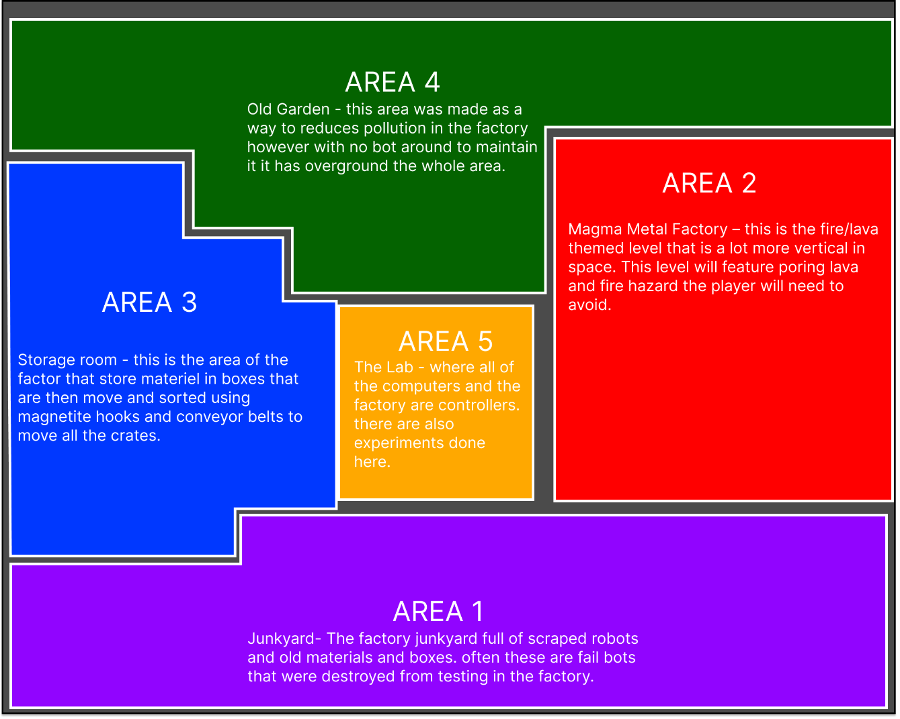

4 Distance area located inside the abandoned faction with only the remains of the robots left in its place.

Each of the areas has to save zones that the player can use to save the game progress as well as heal the player to full health.

## Area 1: Factory Junkyard

* scrap metal graveyard -This is where all leftover junk and scrap goes until it’s processed through the factory for dismantlement or just recycled into new parts. Many of the robots here have already been deactivated before being scraped into the grave although some are still just barely functioning. This is the very first starting area the player will start in and will serve as the tutorial level.

**Enemies:**

* Walker - Once a worker robot, but now it roams the area looking out for anything that is detected as “dangerous”. Shooting its rifle in three short bursts from afar and does a melee attack when the player is too close.
* Hunter - Agile, and precise, the Hunter is eager to hunt and is able to pounce at anyone in one and bleeds its foe.

**Items and Level gimmick:**

* Lock doors and keys
  + 2 lock doors (one open with a key) (other opens by a switch)
* Switches - that can be shot with the gun.
  + Switch that will open one lock door.
  + Switch that will make platforms appear or move.
* boxes - block the pathway and can be destroyed with the blade.
  + Boxes will reappear after leaving the room.
* Crushers – blocks that will fall from above that can do damage to the players.
* A few Power Ups & Weapons/ Abilities will be located around this area.

**Power Ups & Weapons/ Abilities:**

* Energy Blade
* Plasma gun
* Dash

**Area 1 timeline**

* The Player starts in the open in area 1.
* The player will platform up a wall (2 rooms)
* The Player will get the energy blade.
* The player will find a lock door.
* The player will find the key to lock the door.
* The player will be blocked out of going down. They will need to activate a switch.
* Player will gain a gun (use to turn on a switch far away).
* Players will get the first key card.
* Play needs to escape from hunter.
* Play will reach the room with an elevator (using the key card to activate it).

## Area 2: Magma Metal Factory

* Magma Metal Factory – this is the fire/lava themed level that is a lot more vertical in space. This level will feature poring lava and fire hazard the player will need to avoid.

**Enemies:**

* Same as area 1
* Super hunter 2

**Items and Level gimmick:**

* Lock doors and keys: total of 3 lock doors and 3 keys
* Switches – 4 switches that will activate and deactivate lava.
* boxes - block the pathway and can be destroyed with the blade.
* There are falling obstacles - that will fall from above that can do damage to the players.
* A few Power Ups & Weapons/ Abilities will be located around this area.
  + New to this area
* Lava – the floor is lava where if the player touches the lava will damage if they are in the lava. Lava is also pouring out in a few walls.
* Cool lava – the same lava can be cooled down by a switch to help travers the area.

**Power Ups & Weapons/ Abilities:**

* Water pump: player can hold on to water to use for both shooting and higher jumps.
  + Hold down the water pump button (if you have water) then press shoot. Shoot out water too cool lava
  + Hold down the water pump button (if you have water) then press jump to do a high jump. You will jump much higher.

**Area 2 timeline**

* Player arrives from the elevator.
* Players will then need to navigate down for a key and unlock the above area.
  + Player can go left to see area 5 (final area)
* Players will need to avoid lava and find the next key to open the area down further to the right.
* Player will then gain access to the water ability (room will trap them in a high place so player need to use the ability to escape out.
* The player will then climb back up to get the last key and unlock the last door to get the next keycard.
* After getting the key card the new hunter of said area will start chasing the player.
* The player will escape the hunter and get to the elevator to move to area 3.

## Area 3: Storage Room

* Storage room - this is the area of the factory that stores materiel in boxes that are then move and sorted using magnetite hooks and conveyor belts to move all the crates.

**Enemies:**

* Same as area 1
* Super hunter 3

**Items and Level gimmick:**

* Lock doors and keys: total of 2 lock doors and 2 keys
* Switches – 2 switches that will activate magnetic hooks.
* boxes - block the pathway and can be destroyed with the blade.
* There are falling obstacles - that will fall from above that can do damage to the players.
* A few Power Ups & Weapons/ Abilities will be located around this area.
  + New to this area
* Magnetic boxes – using the magnetic grab allow for picking up box out of reach.
* Magnetic hooks – using the magnetic hook.
* Conveyor belt – can be on the floor or on the ceiling (with hooks) that will move anything in one direction.
* The vertical conveyor belt – only goes up and allows the player to climb up with the magnetic hook.

**Power Ups & Weapons/ Abilities:**

* Magnetic Grab: allows the player to grab metal boxes. They can also magnetically grab hooks (like a grapple beam)

**Area 3 timeline**

* Player arrives from the elevator.
* Player will the roam around until seeing a long hallway with spikes all the way.
* The player will go to another room until finding a locked door.
* The player will then find a key and go back to open door (short distant)
* Player will then find the magnetic grab ability.
* Player will go back long hallway and use the grab to travel the long spike hallway via magnetic hooks.
* Player will then find the next key that will unlock the last door.
* The player will use magnetic grab to each lock door and then get keycard 3
* The hunter will then start chasing the player with the key card.
* Player will need to navigate back to the elevator.

## Area 4: Old Garden

* Old Garden - this area was made as a way to reduce pollution in the factory however with no bot around to maintain it has overground the whole area.

**Enemies:**

* Same as area 1
* Super hunter 4

**Items and Level gimmick:**

* Lock doors and keys: total of 4 lock doors and 4 keys
* Switches – will activate platforms and water pumps.
* boxes - block the pathway and can be destroyed with the blade.
* There are falling obstacles - that will fall from above that can do damage to the players.
* A few Power Ups & Weapons/ Abilities will be located around this area.
  + New to this area
* vines and trees – are used as things that can be climbed on with claws.
* Webs – use the claw attack to remove them blocking path.
* Grow sapling – water them to make trees or vines that can be used or can grow to be platforms.

**Power Ups & Weapons/ Abilities:**

* Claws – allow the player to climb on vines or trees.
  + You can melee with the claw to remove things like spider webs.

**Area 4 timeline**

## Area 5: The Lab

(Current scrap- will be used instead as the end game goal)

* The Lab - where all the computers and the factory are controllers. There are also experiments done here.

**Enemies:**

* Same as area 1
* Super hunter _____ -

**Items and Level gimmick:**

* Lock doors and keys:
* Switches – 4 switches that will activate and deactivate lava.
* boxes - block the pathway and can be destroyed with the blade.
* There are falling obstacles - that will fall from above that can do damage to the players.
* A few Power Ups & Weapons/ Abilities will be located around this area.
  + New to this area
* N/a

**Power Ups & Weapons/ Abilities:**

* N/a

**Area 5 timeline**

# Level MOCKUP Pics

## Area 1:

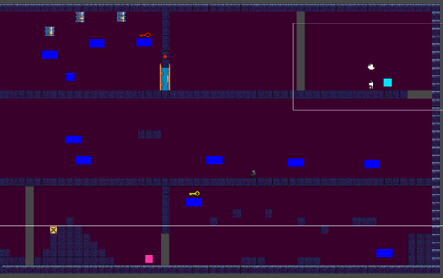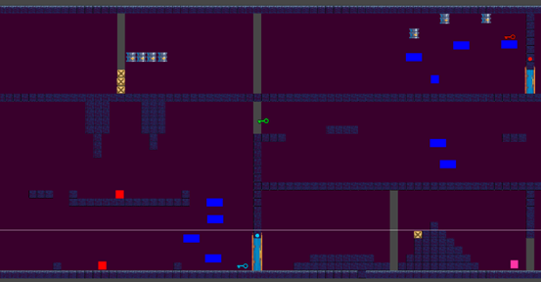

# **Interface**

**UI**

**Title Screen**:



* The title Screen will have the name of the game, when robots bleed, in bold font maybe in an artistic font. Maybe With art related to the game and genre(s) of the game.

**Main menu**:

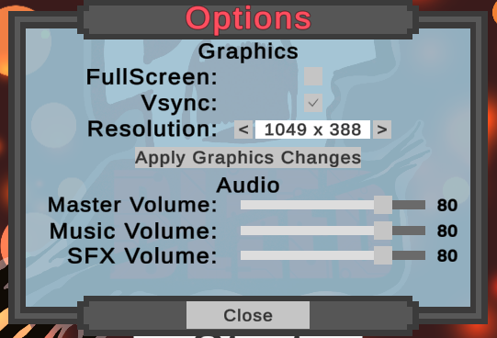

The main menu will include:

* Continue (game) - this will only show for those that already have a save point/ save files
* New Game (2nd part of Capstone or maybe) - you will be able to choose the name of your character, might include difficulty levels
* Load Game (2nd part of Capstone or maybe) - will consist of all save files
* Options - will include game, game controls, video, audio
* Exit Game
* New Game+ (maybe)

**Pause menu**:

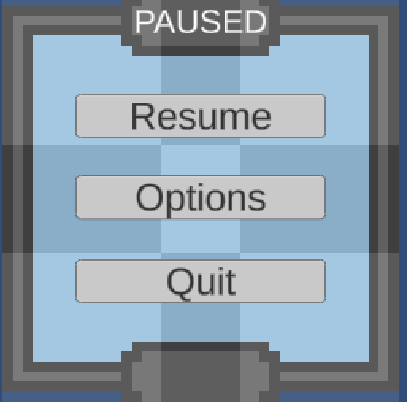

* continue/ resume
* save game (2nd part of Capstone or maybe) - where you can do a quick save
* load game (2nd part of Capstone or maybe) - you will be able to load up a save file and where you can also save the game
* options - will include game, game controls, video, audio
* Exit to main menu
* exit game

**Inventory (***Scraped for this semester***)**:

* Any consumables, items, and upgrades will be found here

**Skill tree (***Scraped for this semester***)**:

* After acquiring your weapons and abilities, you will be able to upgrade them here.
* It might include more powerful versions of those abilities or even new abilities that work in conjunction with your other abilities, weapons, and movesets.
* These abilities might go hand to hand with the character's level if we decide to include a level system.

# **Audio**

## **Music**

**Title screen:**

* A Cyberpunk/Trance theme plays, invoking a sense of seriousness and danger—a theme constant throughout the game.

**Main menu:**

* A softer version of the Title screen theme plays so the player is not over stimulated by the intense music while interacting with their options, save files, and gameplay.

**Player:**

* The player will have a dedicated theme for them, this will play at pivotal points in the game and play in different genres:
  + **Ballad:** A softer and more orchestral version of the player’s theme—plays during more emotional parts of the game.
  + **Cyberpunk/Trance**: A more synthesized and upbeat version of the player’s theme—matches the game’s overall tone and exemplifies the robotic nature of the character and theme.
  + **Industrial Metal:** A heavy and monstrous theme that plays during intense moments of game, such as the final battle/
  + **Lullaby:** A very simple and calming version of the theme that plays at the end, to let the player relax and recount what happened during their gameplay.
  + **Death:** A short Lo-Fi death jingle for when the player dies.

**Bosses (***This section of the project will be moved to the 2nd semester part and scraped for the prototype stage***):**

* Each boss get’s their own custom theme to match their overall aesthetic and combat style

**Starting zone:**

* An eerie ambient theme plays while the player navigates around the forest and broken path to the laboratory. This theme would consist of acoustic and synthetic sounds to show contrast between industrialized life and rural/natural life.

**Area 1:**

* Area 1’s theme is not as intense as its succeeding area’s themes, but captures the tone of death and decay of the decrepit robots barely clinging to life. A Techno theme with most of the instruments being machine-like and more ambient to establish the dark tone of the game.

## **Sound Effects**

**Title, Main menu, & Pause screens:**

* UI button noises for interacting with different features for the title, main menu, and pause screens all having a synthesized sci-fi tune to them:
  + Button noise for hovering over an option
  + Button noise for confirming a selection
  + Button noise for clicking back
  + Button noise for a slider option

**Player:**

* Player specific sounds for weapons, status, and movement:
  + Player footsteps that match the environment the player is in
  + Player dash: A gust of air to indicate the dash
  + Player jump/double jump: A mechanical hinge sound
  + Player hover: A long synthesized gust of air rushing through
  + Weapon gun blast: A shot with an explosion on impact
  + Weapon blade slash: A synthesized laser sound with a clash to indicate a strike
  + Player death sound: A malfunctioning robotic sound that decrescendos down

**Enemies:**

* Different types of enemies will vary in sound based on their appearance and attacks. All enemies will have a robotic alert sound to indicate that they have noticed the player.
  + **Walker:** Gun blaster sounds and heavy footsteps to show its slow pace and reliance on its ranged attacks.
  + **The Hunter:** Slashing sounds for its attacks, a windy sound for its dodge, an air release for its leap attack, and light footsteps to indicate its high agility.

**Bosses (***This section of the project will be moved to the 2nd semester part and scraped for this semester***):**

* Each boss has its own set of sounds for their specific attacks and specials.

**Starting zone:**

* Wind playing the background to emphasize the desolate nature of the area. Because this area is short, the theme playing is most of the audio that will be playing.

**Area 1:**

* Along with the Area 1 theme playing will be certain robots and machines in the background that make noise when the player passes by them. Certain interactables will also make sounds.

# Enemies and Bosses

Enemies in general will most likely have an indicator on when it's going to attack, like a glowing red marker on top of their head showing that they are ready to attack

**Walker**

* **Movement and attacks**
  + Left and right movement
  + Shoots three pellets when player is in sight on the same level
* **How to beat (depending on the level of player or weapon could be lower)**
  + 3 hits with the melee weapon
  + 4 hit with ranged

**Crawlers**

* **Movement and attacks**
  + Moves one direction but will follow the wall.
* **How to beat (depending on the level of player or weapon could be lower)**
  + 1 hit with the melee weapon.
  + 2 hits with ranged.

**Shooters**

* **Movement and attacks**
  + Stand still in one place and shoot a projectile left or right if it see the player.
* **How to beat (depending on the level of player or weapon could be lower)**
  + 2 hits with the melee weapon
  + 4 hits with ranged

**Hunter**

* **Movement and attacks**
  + Left and right movement
  + Can jump/teleport up to or down to platforms to where player is currently located
  + When the Hunter is attacking, It will jump forward to attack
* **How to beat (depending on the level of player or weapon could be lower)**
  + Melee is the only option to deal damage to it
    - 2 hits with the melee weapon
  + Ranged is ineffective and will be dodged by the Hunter
    - N/A hits for ranged

**Type of Hunter**

* + Each hunter is unique to each zone.
  + The Hunter will have one unique way of getting the player.
* Hunter in area 1
  + Has Average speed. (Little slower speed that player.)
  + Follow the player when in range.
  + Chase the player linearly and only will stop when player is out of sight.
  + Roams at the bottom floor of area 1.
* Hunter in area 2
  + Is much faster in speed.
  + When in range of the player’s sight will fully dash to the player in one direction until it crashes to a wall.
  + Is immune to lava and fire and will ignore them.
* Hunter in area 3
  + Instead of chasing the player this hunter will try to use a grab like attack to grab the player and pull them.
  + The hunter if see the player will take aim and then shoot out their magnetic hook to the player (the player can doge the attack with good movement)
  + The player will need to wiggle out of the grab before the hunter is in range to attack. (Or the player must attach a magnet hook to avoid being grabbed)
* **h**hhjkjdflskjflkasdkl;jkjhwesdfasdfasdfaHunter in area 4
  + **IUUn**Unlike all the other hunters this one can fly and will always chase the player through walls.
  + However, this hunter is much slower than the other 3 hunters before them.
  + This hunter will also shoot the player with sticky webs that the player will need to use claws to remove.

# Technical

**Game Engine:**

* We will be using the game engine Unity, developed by Unity Technologies, to create the game. Specifically, we are using the [LTS 2021.3.18f1 build](https://unity.com/releases/editor/qa/lts-releases). The game will be developed using C#.

**Target System:**

* The game will be developed for PC (Microsoft Windows), with the intention of launching on Steam.

**Version Control:**

* A private repository of all code will be maintained using [Github](https://github.com/).

**Plug-ins and Add-Ons:**

None used yet!

**Code Objects:**

* Player object: This is the character the player controls.
* Enemy objects
  + Basic enemies:
    - Walker
    - Hunter
  + Bosses
* Camera object: Orthographic camera that follows the player object.
* Item objects: Usable, consumables, and collectable items. Some items may be placed into inventory upon picking up
  + Key: For locked doors. Placed into inventory and used when interacting with the corresponding door.
  + Consumables: used automatically upon pick-up. Includes health and bullets for ranged weapons with limited ammunition.
* Interactable environment objects
  + Switches: can be activated by attacking (ranged or melee)
  + Cardboard boxes: destructible objects that block paths and may hold consumables.

**Basic Enemy AI and Mechanics:**

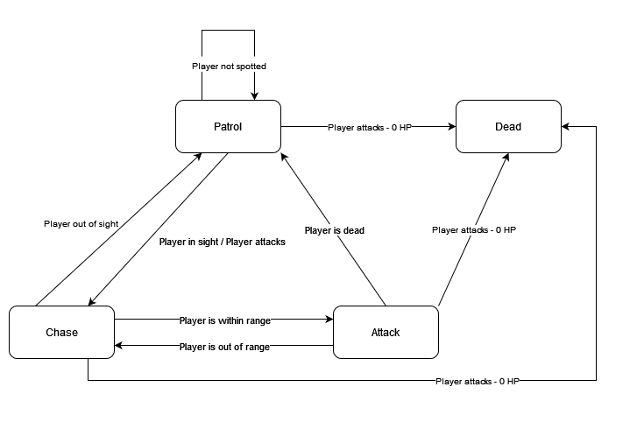

Basic enemies include: the Walker and the Hunter.

**Behavior** *(see FSM above)*:

* Basic enemies have a patrol range. The enemies will continue to patrol until 1) Player attacks or 2) Player is spotted within sight range. If the player attacks an enemy and enemy HP is calculated <=0, the enemy dies.
* When the player is spotted, or after the player attacks the enemy unspotted (ambush from behind) and doesn’t deal mortal damage, the enemy goes into chase state.
* If the player is within the enemy’s attack range, the enemy will attack.
* If the player leaves the enemy’s sight or patrol range for an amount of time, the enemy will disengage and transition back to patrol state.
* The range in which an enemy can chase the player may be different from its patrol area.

**Specific Monster Behavior Notes:**

* **Walker:**
  + This is a very basic enemy that follows the behavior discussed above.
* **Hunter:**
  + The Hunter has a very large patrol/chase range and should be able to pursue the player over longer distances.
  + The hunter’s sight range when patrolling should be moderate to allow players to try and evade them.
  + It should be harder for the player to cause Hunter enemies to disengage or lose interest, however. The time it takes to lose interest in the player when the player is “out of sight” should be longer.

# Game Art

